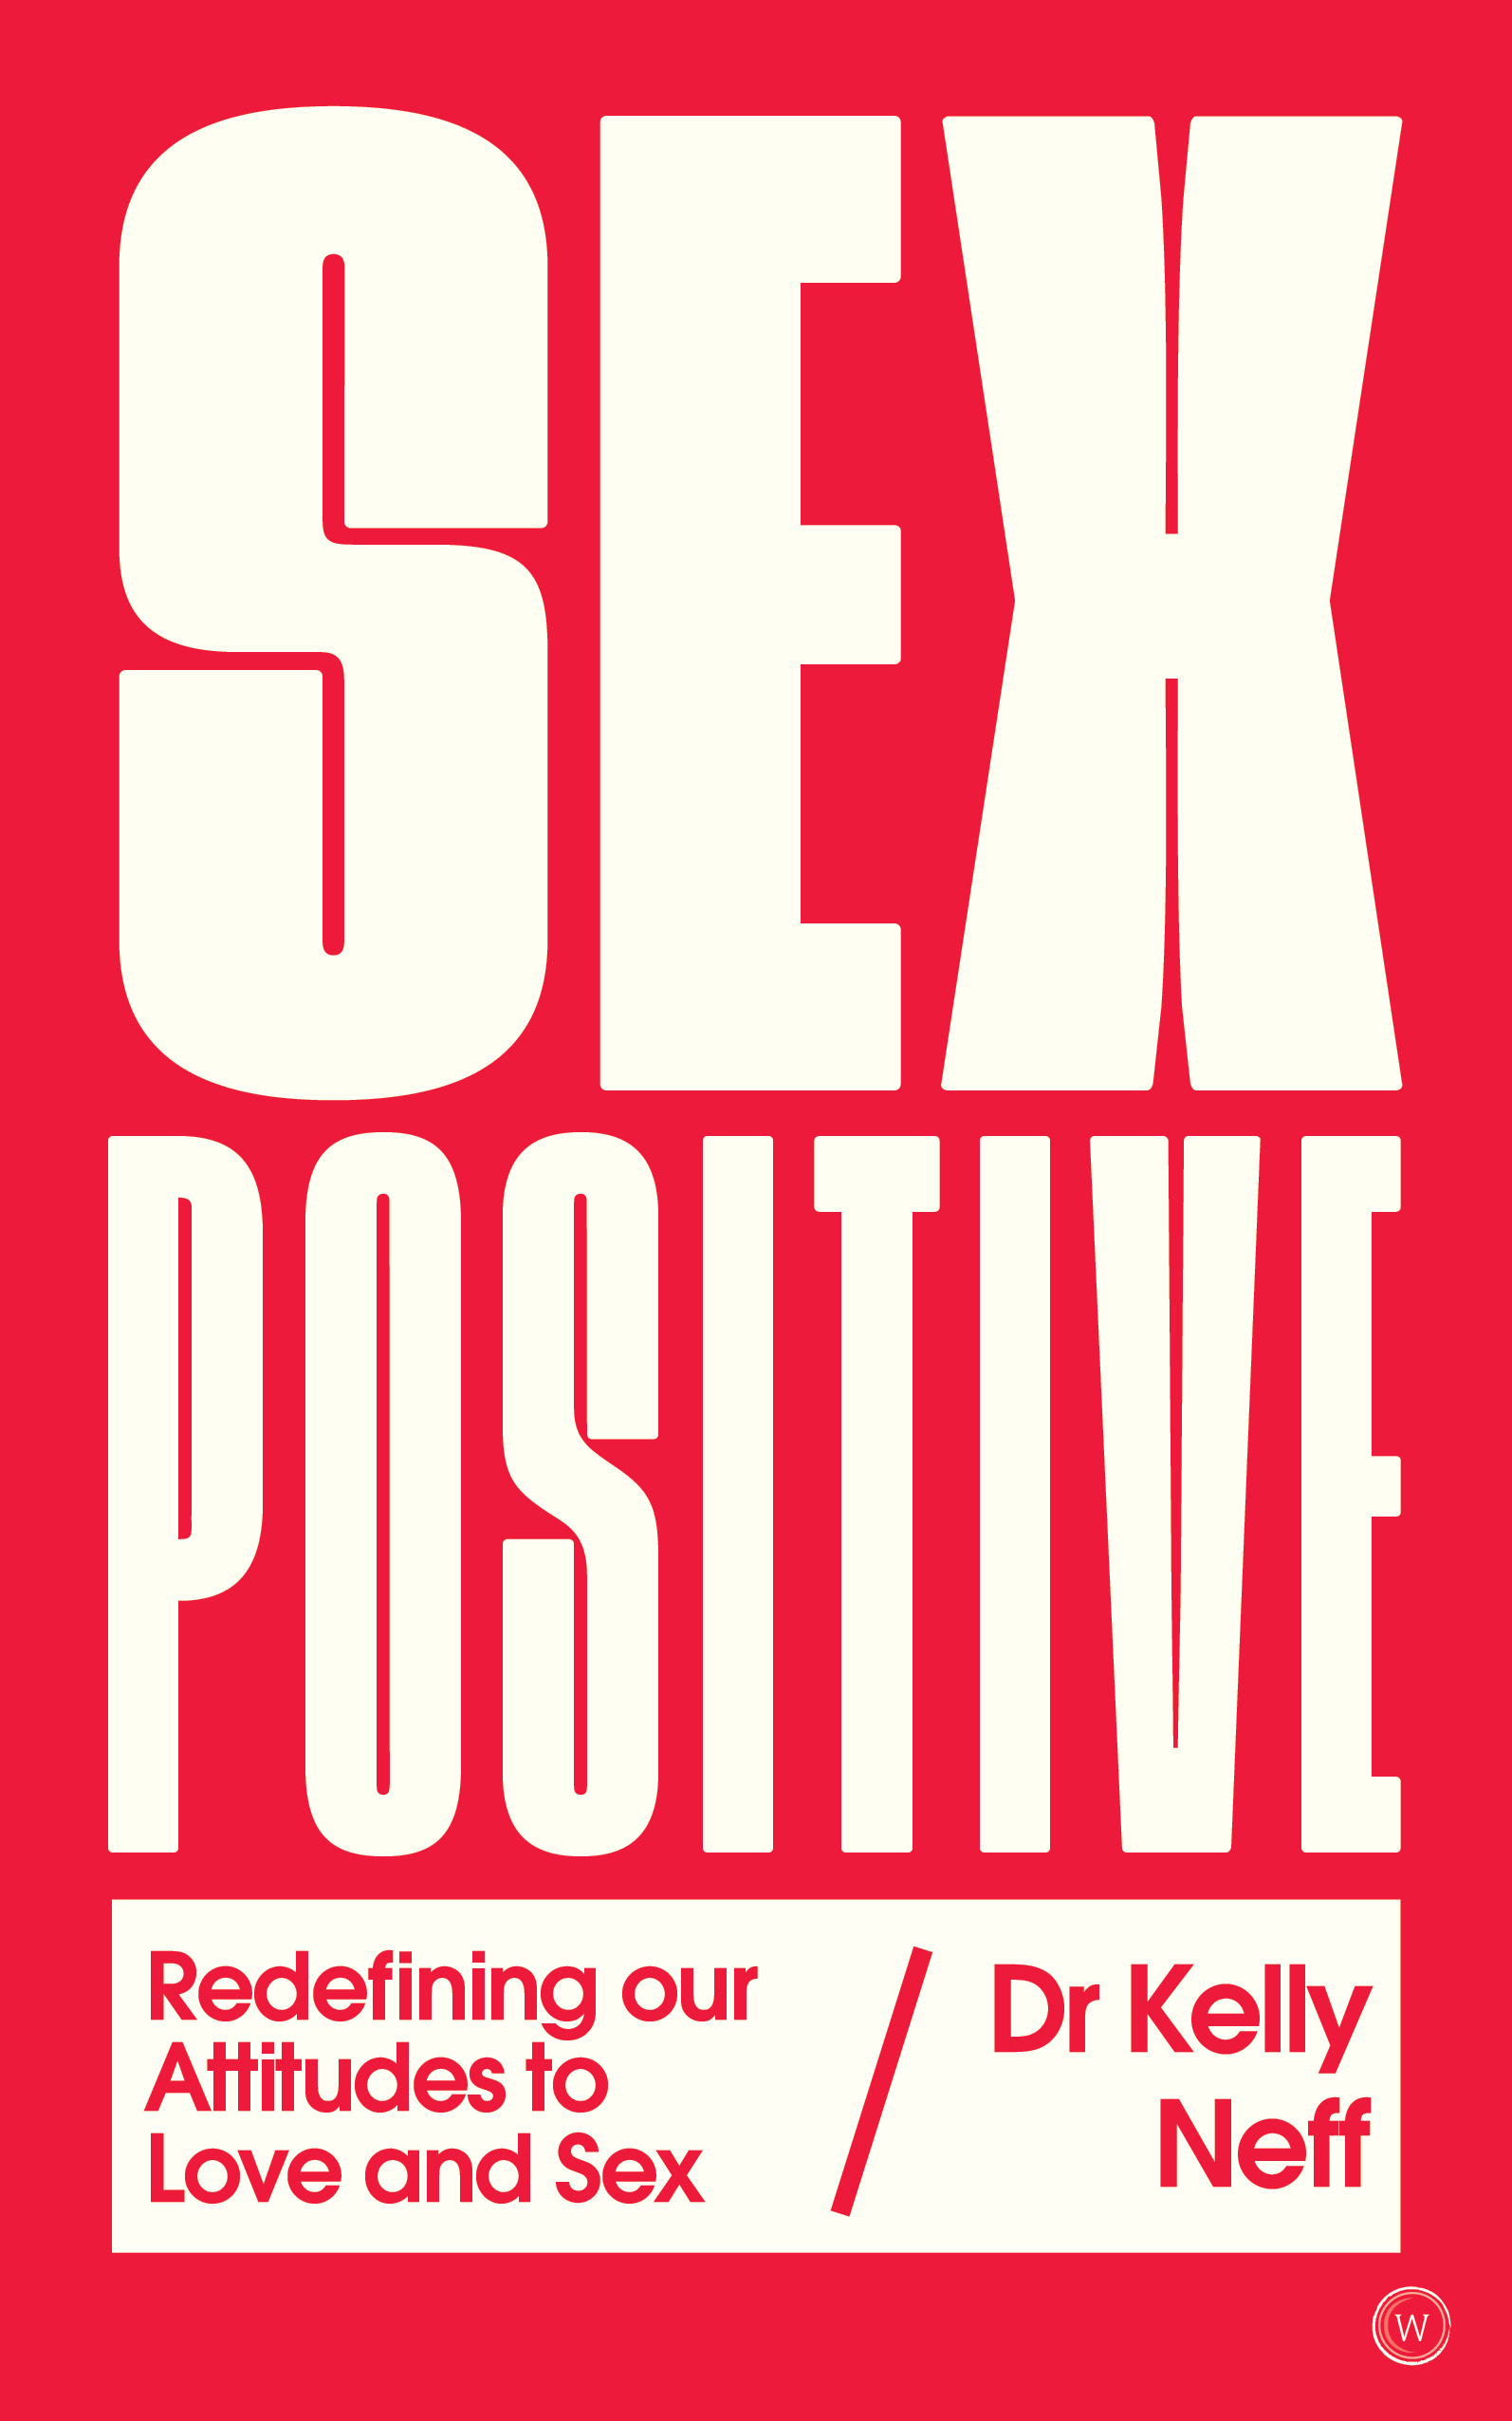
SEX POSITIVE
Redefining our Attitudes to Love and Sex
By Dr Kelly Neff

11th February 2020 | Paperback | £14.99/$18.95

The digital age is ushering in a new sexual revolution, and it is Sex Positive.

Millennial disrupter Dr. Kelly Neff believes a radical change is underway in our love and sex lives — a transformation fueled by technology and shifting cultural beliefs. Millennials and Generation ‘Z’ are rejecting traditional gender stereotypes and embracing tech as it revolutionizes virtually every aspect of our sex lives. The future is Sex Positive — tolerant of individual choice and open to sexual freedom and exploration, but what does this mean for our sex lives and our definitions of love as we navigate this brave new world of sexual autonomy and self-discovery?

Social psychologist Dr. Kelly Neff boldly addresses the rise of non-monogamous relationships, the pitfalls of online dating, gender fluidity, female orgasm and robotic sex partners among many other contentious issues emerging as part of the massive ongoing social and political shits surrounding sex, love and identity. Neff calls for sexual fearlessness, acceptance, and a progressive, tolerant attitude that allows all individuals the freedom to explore love, sex, identity, and non-traditional relationships. She fuses scientific sexology research, psychological theorizing, Eastern and Western philosophies and stories from around the world to provide a fresh, affirmative take on the psychology of human sexuality.

The first part of the book addresses significant cultural trends such as rejecting traditional gender stereotypes in favor of gender fluidity, as well as the titillating technological advances that are poised to change everything about love and sex as we know it. Part two explores our changing identities, from reframing sex as a “spiritual” experience, to reclaiming and better understanding the female orgasm, as well as delving into the process of healing our sexual wounds through belief change, forgiveness and flow. The third and final part of the book offers thoughtful tools to help create and maintain Sex Positive relationships, including what it means to find a soulmate, experimenting with non-monogamous relationships and tips to survive the trials of modern online dating.

Never before has there been a stronger cultural narrative about fiercely loving and accepting yourself without shame, guilt or judgement. Dr Kelly is here to unpack the big topics and create a dialogue about what really matters today when it comes to what we want out of love, sex and relationships.

In Sex Positive Dr Kelly unpacks:
Healing and recovery from the #Metoo revelations & toxic masculinity
The importance of consent
Body positivity & genital acceptance
The impending arrival of robotic sex partners and what it means for human relationships
Reclamation of the female orgasm & female sexual autonomy
New ways of understanding gender
How millennials are bringing spiritualty (but not religion) back to sex
What millennials are looking for in their long-term partners
The health benefits of sex
The rise of non-monogamous relationships
“The concept of the sex positive movement is one that I believe can benefit many people in all walks of life and relationships. It’s not a movement solely for women, but one that can apply to all genders and lifestyles. Being sex positive is inherently inclusive, and this is the tone that I take in this book.”
– Dr Kelly Neff, from Sex Positive

About Dr Kelly Neff
Dr Kelly Neff is a social psychologist, professor, futurist, radio personality and author who has electrified the media world with her unique focus on the intersection of psychology, consciousness, and human sexuality. An academically trained research psychologist, she received her B.A. (2004) in Psychology magna cum laude and Phi Beta Kappa from Georgetown University and her M.A. (2006) and Ph.D. (2010) in Social Psychology summa cum laude from Claremont Graduate University. She spent almost a decade teaching thousands of people in her online and in-person Psychology of Human Sexuality courses at Saddleback College, CA.

Twitter: @TheLucidPlanet | Facebook: TheLucidPlanetwithDrKelly

Dr Kelly Neff will be in the UK around the time of publication for interviews.

For more information or to see an advanced proof, please contact
Cynthia Hamilton | cynthia.hamilton@watkinspublishing.com

